Adventure Groups
Booking Form:
Date:
Name of Uniform group:
No. of children:
No. of supervising adults (with fee paying children):
No. of supervising adults (extra to be paid):
Do you agree to our Behaviour, Animal contact requirements?

Would you like to include your badge giving ceremony?

Main Point of Contact:
Name:
Contact number:
Contact email:

Invoice contact:
Name:
Contact number:
Contact email:
Address:

Adults are permitted at the NSPCC recommended supervision rates for fee paying children. Additional supervising adults are charged at £5.00 per person.
Age: | Adult-Child Ratio:
0-1 | 1:3 (fee paying children only)
2-3 | 1:4 (fee paying children only)
4-8 | 1:6
9-12 | 1:8
13-18 | 1:10
:

Behaviour & Animal Contact Requirements:
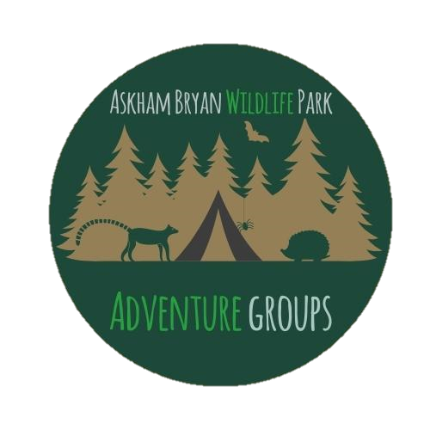
Learner Behaviour:
Learners must be supervised at all times, and must follow the instructions of staff.
Askham Bryan Wildlife and Conservation Park will not accept responsibility for any person disregarding health and safety guidelines or neglecting to follow safe working practices implemented by its trained education staff.
Food and drink may not be consumed during the tour. (bottled drinks are permitted that can be safely put away in a secure bag)
Those with a compromised immune system will not be permitted to be in close contact with live animals (this includes pregnant women, children aged 2 and under and people health conditions or medications affecting the immune system).
If you have any particular health and safety or accessibility needs please ensure that we are aware of these before the day.
Animal Contact:
The Wildlife Park is our animal’s home and as a modern zoological facility, we have a duty of care for all animals on-site. With this in mind, we are no longer offering direct animal handling during guided visits – this is to help ensure that our animals are happy and stress free. It is much more enjoyable, safe and important that we are able to observe and enjoy seeing animals in their natural environment.

